ADITYA UNIVERSITY
Surampalem
Department of Computer Science and Engineering
DBMS CAPSTONE PROJECT
Project Documentation Report
Project Title:
BANK ACCOUNT MANAGEMENT SYSTEM
Submitted by:
S.No | Student Name | Roll Number
1 | G.Sashank | 25B11AI316
2 | G.Manoj | 25B11AI385
3 | V.Pavithra | 25B11AI520
4 | B.Harika | 25B11AI527

Course: Database Management Systems(DBMS) Course Code:

Faculty Coordinator: G L Narasamba Vanguri

Academic Year:2026 Date of Submission: ____________

GitHub Repository Link: https://github.com/sashank-1916/bank-account-management-dbms.git

TABLE OF CONTENTS
(Right-click the table below and choose "Update Field" in Microsoft Word to refresh page numbers.)
TABLE OF CONTENTS 1
1. ABSTRACT 1
2. INTRODUCTION 1
2.1 Background 1
2.2 Purpose of the Database 1
2.3 Existing System 1
2.4 Proposed System 1
2.5 Scope of the Project 1
3. PROBLEM STATEMENT 1
4. OBJECTIVES 1
5. FEASIBILITY STUDY 1
5.1 Technical Feasibility 1
5.2 Economic Feasibility 1
5.3 Operational Feasibility 1
5.4 Schedule Feasibility 1
6. SYSTEM REQUIREMENTS 1
6.1 Hardware Requirements 1
6.2 Software Requirements 1
7. SYSTEM ANALYSIS & DESIGN METHODOLOGY 1
8. DATABASE DESIGN 1
8.1 Identified Entities 1
8.2 Data Dictionary (Entity Attributes) 1
8.3 ER Diagram (Detailed — Chen Notation) 1
8.4 Relationships & Cardinality 1
8.5 Relational Database Schema 1
8.6 Normalization 1
8.6.1 Unnormalized Form (UNF) 1
8.6.2 First Normal Form (1NF) 1
8.6.3 Second Normal Form (2NF) 1
8.6.4 Third Normal Form (3NF) 1
9. DATA FLOW DIAGRAMS 1
9.1 DFD Level 0 — Context Diagram 1
9.2 DFD Level 1 1
10. USE CASE DIAGRAM 1
11. DATABASE IMPLEMENTATION 1
11.1 DDL — Database and Table Creation 1
11.2 Sample Data — DML 1
11.3 Constraints & Data Integrity 1
11.4 SQL Operations & Queries 1
Query 1 — Filter by Account Type 1
Query 2 — Join Account with Customer 1
Query 3 — Aggregate with GROUP BY 1
Query 4 — HAVING Clause 1
Query 5 — Subquery 1
Query 6 — Multi-table Join 1
Query 7 — View Creation 1
Query 8 — UPDATE Statement 1
Query 9 — DELETE Statement 1
Query 10 — ORDER BY with LIMIT 1
Query 11 — Correlated Subquery (EXISTS) 1
Query 12 — Reporting View 1
11.5 Sample Outputs / Screenshots 1
12. MODULES & FUNCTIONALITIES 1
13. TESTING 1
13.1 Testing Approach 1
13.2 Test Cases 1
14. SECURITY CONSIDERATIONS 1
15. ADVANTAGES 1
16. LIMITATIONS 1
17. GITHUB REPOSITORY & TEAM RESPONSIBILITIES 1
18. ENHANCEMENTS & FUTURE IMPROVEMENTS 1
19. CONCLUSION 1
20. REFERENCES 1
APPENDIX A — COMPLETE SQL SCRIPTS 1
A.1 ddl.sql 1
A.2 dml.sql 1
A.3 queries.sql 1
APPENDIX B — ADDITIONAL SCREENSHOTS 1

1. ABSTRACT
The Bank Account Management System is a relational database application designed to automate the core operations of a retail bank, replacing manual, paper-based record keeping with a centralized, consistent, and secure data store. The system manages branches, employees, customers, accounts, transactions, loans, and debit/credit cards across a normalized relational schema. It allows a customer to open one or more savings or current accounts at a branch, perform deposits, withdrawals, and fund transfers, and apply for and repay loans, while bank employees manage day-to-day operations and branch-level records.
The database enforces primary key, foreign key, NOT NULL, UNIQUE, and CHECK constraints to guarantee referential integrity and prevent invalid or duplicate entries such as negative balances or unauthorized overdrafts. Structured Query Language (SQL) is used for schema definition (DDL), data manipulation (DML), and reporting (DQL), including joins, aggregate functions, subqueries, and views for tasks such as computing branch-wise deposits, identifying high-value customers, and tracking overdue loans. Data Flow Diagrams and a Use Case diagram were additionally prepared to document the system's process flow and actor interactions, alongside a formal testing phase to validate constraint enforcement and query correctness.
The resulting design demonstrates the practical application of entity-relationship modeling, normalization up to Third Normal Form (3NF), structured systems analysis, and SQL-based implementation to build a reliable, scalable, and auditable core banking database.

2. INTRODUCTION

2.1 Background
Banks handle a very large volume of daily financial activity — account opening, cash deposits and withdrawals, fund transfers, loan disbursement, and card issuance — all of which depend on the accuracy and availability of customer and account data. Traditional, file-based or manual record-keeping methods are slow, error-prone, and difficult to scale, and they make it hard to enforce data consistency across branches or to generate timely reports. A relational database management system (RDBMS) offers a structured, rule-enforced, and query-driven alternative that keeps data centralized, consistent, and quickly retrievable, which is why banking is one of the classic and most demanding domains for database design.

2.2 Purpose of the Database
The Bank Account Management System database is designed to store and manage information about bank branches, employees, customers, accounts, transactions, loans, and cards in a single consistent structure. It is intended to be used by bank employees and administrators to open and manage customer accounts, record and audit transactions, process loan applications, and generate operational and managerial reports. By centralizing this information, the database eliminates redundant data entry, enforces business rules (such as a minimum balance or valid account types) at the schema level, and supports fast, accurate answers to questions such as a branch's total deposits or a customer's outstanding loan balance.

2.3 Existing System
Many small and mid-sized banking setups currently rely on manual registers, standalone spreadsheets, or legacy desktop applications with no shared database. Under this arrangement, each branch or teller may maintain its own records, account balances are updated manually after each transaction, and there is no single, authoritative source of truth linking a customer to all of their accounts, loans, and cards across branches.
This existing approach suffers from several well-known limitations:
- Data redundancy — the same customer's details may be re-entered at every branch they interact with.
- Update anomalies — a change to a customer's address or phone number in one register does not automatically reflect elsewhere.
- Weak integrity — nothing stops a teller from recording a withdrawal that pushes a balance negative, or from entering a duplicate account.
- Poor auditability — reconstructing a customer's transaction history across time or branches is slow and error-prone.
- Delayed reporting — branch-wise or bank-wide summaries must be compiled by hand instead of being computed instantly.

2.4 Proposed System
The proposed Bank Account Management System replaces this fragmented approach with a single, normalized relational database accessed through SQL. Every branch, employee, customer, account, transaction, loan, and card record lives in one schema with enforced primary key and foreign key relationships, so that data is entered once, referenced everywhere it is needed, and validated automatically by the database engine rather than by manual discipline. Reporting queries that previously required manual compilation — such as branch-wise deposits or a list of overdue loans — become a single SQL statement.

2.5 Scope of the Project
This project covers the design and implementation of the database layer for a bank account management use case: entity-relationship modeling, normalization, schema creation, constraint enforcement, sample data population, and query/report development. It does not implement a graphical front-end or a live network-facing application; interaction is demonstrated through SQL scripts executed in MySQL Workbench, which is consistent with the objectives of a DBMS-focused academic capstone. The data flow and use case diagrams in Sections 9 and 10 describe how a full application would be expected to interact with this database if a front-end were added later (see Section 17, Future Enhancements).

3. PROBLEM STATEMENT
Many small and mid-sized banking setups still rely on manual registers or disconnected spreadsheets to track customer accounts, deposits, withdrawals, and loans. This leads to duplicate customer records, inconsistent balances across branches, delayed or inaccurate reporting, and a high risk of human error when applying interest, computing minimum balances, or reconciling transactions. There is no single source of truth that links a customer to all of their accounts, transactions, loans, and cards, which makes auditing and fraud detection difficult. The proposed Bank Account Management System addresses this by modeling all these entities in a normalized relational schema with enforced integrity constraints, so that every account, transaction, and loan record is uniquely identifiable, correctly linked to its owning customer and branch, and instantly queryable through SQL.

4. OBJECTIVES
- Objective 1: Design a normalized (up to 3NF) relational schema that accurately models branches, employees, customers, accounts, transactions, loans, and cards.
- Objective 2: Implement the schema using DDL with appropriate primary key, foreign key, NOT NULL, UNIQUE, CHECK, and DEFAULT constraints to enforce data integrity.
- Objective 3: Populate the database with realistic sample data and demonstrate core banking operations (deposit, withdrawal, transfer, loan disbursement) using DML statements.
- Objective 4: Write representative SQL queries — joins, aggregate functions, GROUP BY/HAVING, subqueries, and views — to support day-to-day banking operations and management reporting.
- Objective 5: Model the system's process flow and actor interactions using Data Flow Diagrams and a Use Case diagram.
- Objective 6: Demonstrate referential integrity and data consistency across related tables through a structured testing phase, and document the design, implementation, and testing process.

5. FEASIBILITY STUDY
Before implementation, the project was evaluated for feasibility along four standard dimensions to confirm that it could be completed within the constraints of an academic capstone.

5.1 Technical Feasibility
The project uses MySQL 8.0 and MySQL Workbench, both free and widely available on Windows, Linux, and macOS. No specialized hardware is required beyond a standard desktop or laptop, and the SQL skills needed (DDL, DML, joins, subqueries, views) fall within the syllabus of a standard DBMS course. The project is therefore technically feasible for a student team to complete without external tools or paid licenses.

5.2 Economic Feasibility
All software used — MySQL Community Edition, MySQL Workbench, GitHub, and draw.io/diagrams.net for diagramming — is free and open-source or free-tier. There is no licensing cost, hosting cost, or hardware investment required, making the project economically feasible for a student project with zero budget.

5.3 Operational Feasibility
The resulting database is simple enough for bank employees with basic computer literacy to interact with (via SQL or, in a future extension, a front-end built on top of it, as discussed in Section 17). The schema mirrors real banking concepts (branches, accounts, transactions, loans, cards) that employees would already be familiar with, minimizing the learning curve for operational adoption.

5.4 Schedule Feasibility
The scope — a single-domain relational schema with under 10 tables, and no front-end — is achievable within a typical academic semester timeline, including design, implementation, testing, and documentation phases, when divided across a 4-member team as shown in Section 16.

6. SYSTEM REQUIREMENTS

6.1 Hardware Requirements
Component | Minimum Requirement
Processor | Dual-core 1.6 GHz or equivalent
RAM | 4 GB (8 GB recommended)
Storage | 500 MB free disk space for MySQL server and sample data
Display | 1366 x 768 resolution or higher

6.2 Software Requirements
Category | Tool / Technology Used
Database Server | MySQL 8.0
Query / Admin Tool | MySQL Workbench
Front-end (if any) | Not implemented — SQL-only backend demonstration
Operating System | Windows 11 / Ubuntu 22.04
Version Control | GitHub
Diagramming Tool | draw.io (diagrams.net)

7. SYSTEM ANALYSIS & DESIGN METHODOLOGY
The project followed a simplified Waterfall-style Software Development Life Cycle (SDLC), appropriate for a fixed-scope academic database project where requirements were well understood from the outset:
- Requirement Analysis — identifying the core banking entities and operations to be modeled (Section 2, 3).
- System Design — entity-relationship modeling, normalization, and schema design (Section 8).
- Implementation — writing and executing DDL and DML scripts in MySQL (Section 11).
- Testing — validating constraints and query correctness against sample data (Section 13).
- Documentation — compiling this report and the GitHub repository (Section 16).
A Waterfall approach was chosen over an iterative model because the entities and relationships in a bank account system are well-established and unlikely to change mid-project, making heavy iteration unnecessary for a documentation-focused capstone.

8. DATABASE DESIGN

8.1 Identified Entities
S.No | Entity Name | Description
1 | Branch | Represents a physical bank branch that manages accounts and employs staff.
2 | Employee | Bank staff member assigned to a branch who processes customer requests.
3 | Customer | An individual who holds one or more accounts with the bank.
4 | Account | A savings or current account opened by a customer at a branch.
5 | Transaction | A deposit, withdrawal, or transfer performed on an account.
6 | Loan | A loan (personal, home, or vehicle) availed against a customer account.
7 | Card | A debit or credit card issued against an account.

8.2 Data Dictionary (Entity Attributes)
The table below lists every attribute captured for each entity, its data type, key role, and attribute classification (Simple, Composite, Multi-valued, or Derived).
Entity | Attribute | Data Type | Key | Attribute Type
Branch | Branch_ID | INT | PK | Simple
Branch | Branch_Name | VARCHAR(50) | — | Simple
Branch | City | VARCHAR(30) | — | Simple
Branch | IFSC_Code | CHAR(11) | — | Simple
Employee | Employee_ID | INT | PK | Simple
Employee | Branch_ID | INT | FK | Simple
Employee | Name | VARCHAR(50) | — | Simple
Employee | Designation | VARCHAR(30) | — | Simple
Employee | Salary | DECIMAL(10,2) | — | Simple
Customer | Customer_ID | INT | PK | Simple
Customer | Name | VARCHAR(50) | — | Simple
Customer | Aadhar_No | CHAR(12) | — | Simple
Customer | Phone | VARCHAR(15) | — | Multi-valued
Customer | Email | VARCHAR(50) | — | Simple
Customer | Address | VARCHAR(100) | — | Composite
Account | Account_No | INT | PK | Simple
Account | Customer_ID | INT | FK | Simple
Account | Branch_ID | INT | FK | Simple
Account | Account_Type | VARCHAR(15) | — | Simple
Account | Balance | DECIMAL(12,2) | — | Derived
Account | Open_Date | DATE | — | Simple
Transaction | Transaction_ID | INT | PK | Simple
Transaction | Account_No | INT | FK | Simple
Transaction | Txn_Type | VARCHAR(10) | — | Simple
Transaction | Amount | DECIMAL(12,2) | — | Simple
Transaction | Txn_Date | DATETIME | — | Simple
Loan | Loan_ID | INT | PK | Simple
Loan | Account_No | INT | FK | Simple
Loan | Loan_Type | VARCHAR(20) | — | Simple
Loan | Principal_Amount | DECIMAL(12,2) | — | Simple
Loan | Interest_Rate | DECIMAL(4,2) | — | Simple
Loan | Status | VARCHAR(15) | — | Simple
Card | Card_No | CHAR(16) | PK | Simple
Card | Account_No | INT | FK | Simple
Card | Card_Type | VARCHAR(10) | — | Simple
Card | Expiry_Date | DATE | — | Simple
Attribute Type key: Simple / Composite / Multi-valued / Derived.

8.3 ER Diagram (Detailed — Chen Notation)
For a fuller view of every attribute, the diagram below presents the same schema in classic Chen notation: rectangles for entities, ellipses for attributes (with the primary key underlined, a dashed ellipse for the multi-valued Phone attribute, and a dash-dot ellipse for the derived Balance attribute), and diamonds for relationships.
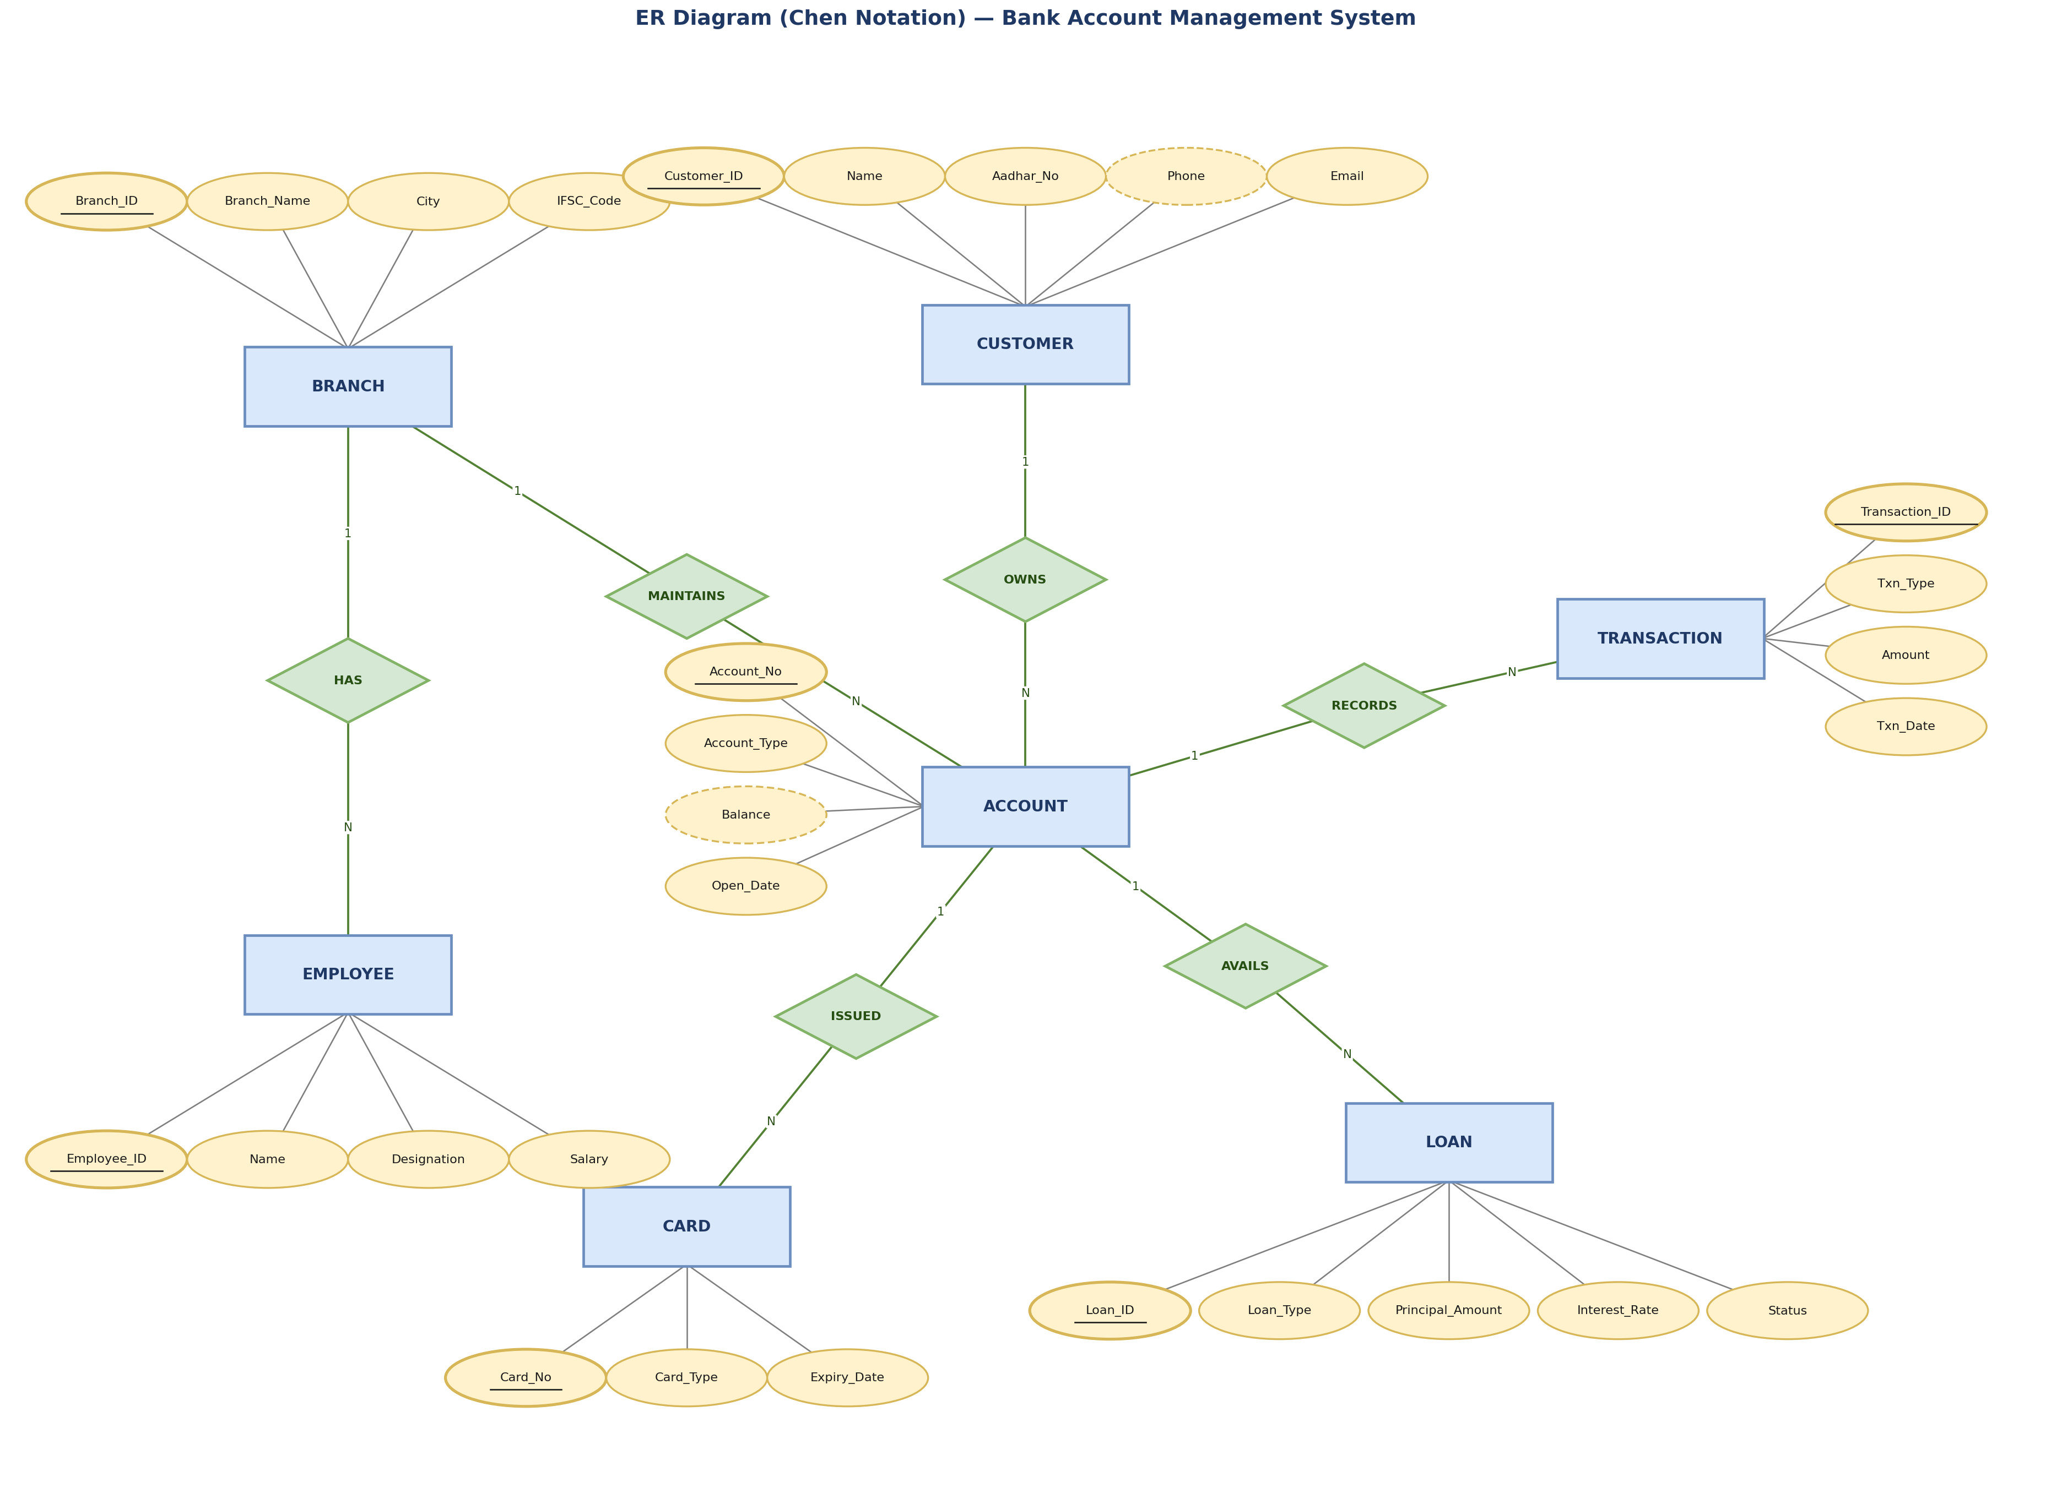
Figure 8.2 — Detailed ER Diagram in Chen Notation

8.4 Relationships & Cardinality
Entity 1 | Relationship | Entity 2 | Cardinality
Branch | has | Employee | 1 : N
Branch | maintains | Account | 1 : N
Customer | owns | Account | 1 : N
Account | records | Transaction | 1 : N
Account | avails | Loan | 1 : N
Account | issued | Card | 1 : N

8.5 Relational Database Schema
Table Name | Column Name | Data Type | PK/FK | Constraints
Branch | Branch_ID | INT | PK | AUTO_INCREMENT
Branch | Branch_Name | VARCHAR(50) | — | NOT NULL
Branch | IFSC_Code | CHAR(11) | — | UNIQUE, NOT NULL
Employee | Employee_ID | INT | PK | AUTO_INCREMENT
Employee | Branch_ID | INT | FK → Branch | NOT NULL
Employee | Salary | DECIMAL(10,2) | — | CHECK (Salary > 0)
Customer | Customer_ID | INT | PK | AUTO_INCREMENT
Customer | Aadhar_No | CHAR(12) | — | UNIQUE, NOT NULL
Account | Account_No | INT | PK | AUTO_INCREMENT
Account | Customer_ID | INT | FK → Customer | NOT NULL
Account | Branch_ID | INT | FK → Branch | NOT NULL
Account | Balance | DECIMAL(12,2) | — | CHECK (Balance >= 0), DEFAULT 0
Transaction | Transaction_ID | INT | PK | AUTO_INCREMENT
Transaction | Account_No | INT | FK → Account | NOT NULL
Transaction | Amount | DECIMAL(12,2) | — | CHECK (Amount > 0)
Loan | Loan_ID | INT | PK | AUTO_INCREMENT
Loan | Account_No | INT | FK → Account | NOT NULL
Card | Card_No | CHAR(16) | PK | UNIQUE, NOT NULL
Card | Account_No | INT | FK → Account | NOT NULL

8.6 Normalization
The schema was normalized up to Third Normal Form (3NF). To illustrate the process concretely, the worked example below traces a small slice of the Account/Customer/Branch data from an unnormalized starting point through to 3NF.

8.6.1 Unnormalized Form (UNF)
Initially, customer, account, and branch details were imagined as a single flat record per customer, with repeating groups for customers holding multiple accounts:
Cust_ID | Cust_Name | Phone(s) | Accounts (Acc_No, Branch, Balance)
1 | Ravi Kumar | 9876543210 | (1, MG Road, 25000), (7, Anna Nagar, 30000)
2 | Anitha Reddy | 9876501234 | (2, Anna Nagar, 50000)

8.6.2 First Normal Form (1NF)
Repeating groups are eliminated by giving each account its own row (atomic values only), and every row is made uniquely identifiable:
Cust_ID | Cust_Name | Phone | Acc_No | Branch | Balance
1 | Ravi Kumar | 9876543210 | 1 | MG Road | 25000
1 | Ravi Kumar | 9876543210 | 7 | Anna Nagar | 30000
2 | Anitha Reddy | 9876501234 | 2 | Anna Nagar | 50000

8.6.3 Second Normal Form (2NF)
The 1NF table above has a composite dependency: Cust_Name and Phone depend only on Cust_ID, not on the full row. These partial dependencies are removed by splitting into a Customer table and an Account table linked by Cust_ID:
Customer Table | Account Table
Cust_ID, Cust_Name, Phone | Acc_No, Cust_ID (FK), Branch, Balance

8.6.4 Third Normal Form (3NF)
In the 2NF Account table, Branch (and any branch attributes like address) would depend on Branch, not directly on Acc_No — a transitive dependency once branch details are expanded (e.g. Branch_Address depends on Branch_Name, not Acc_No). This is removed by extracting a separate Branch table and referencing it via Branch_ID, giving the final 3NF structure used throughout this project:
Customer | Account | Branch
Customer_ID, Name, Phone, ... | Account_No, Customer_ID (FK), Branch_ID (FK), Balance | Branch_ID, Branch_Name, City, IFSC_Code
This same reasoning was applied across all seven entities (Section 8.1) to arrive at the final schema in Section 8.6, in which every non-key attribute depends on the whole primary key and nothing but the key.

9. DATA FLOW DIAGRAMS
Data Flow Diagrams (DFDs) illustrate how data moves between external entities, processes, and data stores within the system, independent of the underlying database implementation.

9.1 DFD Level 0 — Context Diagram
The context diagram treats the entire system as a single process and shows its interaction with external entities: the Customer, Employee/Admin, and Bank Management.
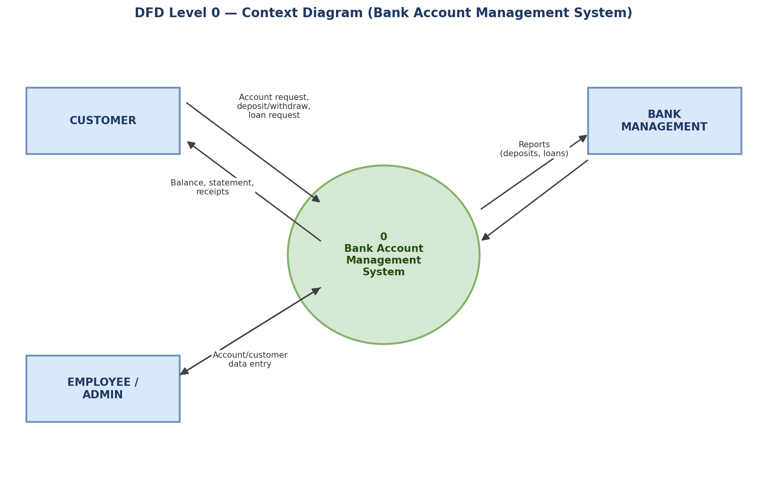
Figure 9.1 — DFD Level 0 (Context Diagram)

9.2 DFD Level 1
The Level 1 diagram decomposes the single process into its major sub-processes — Account Management, Transaction Management, Loan Management, Card Management, and Reporting — along with the data stores each one reads from or writes to.
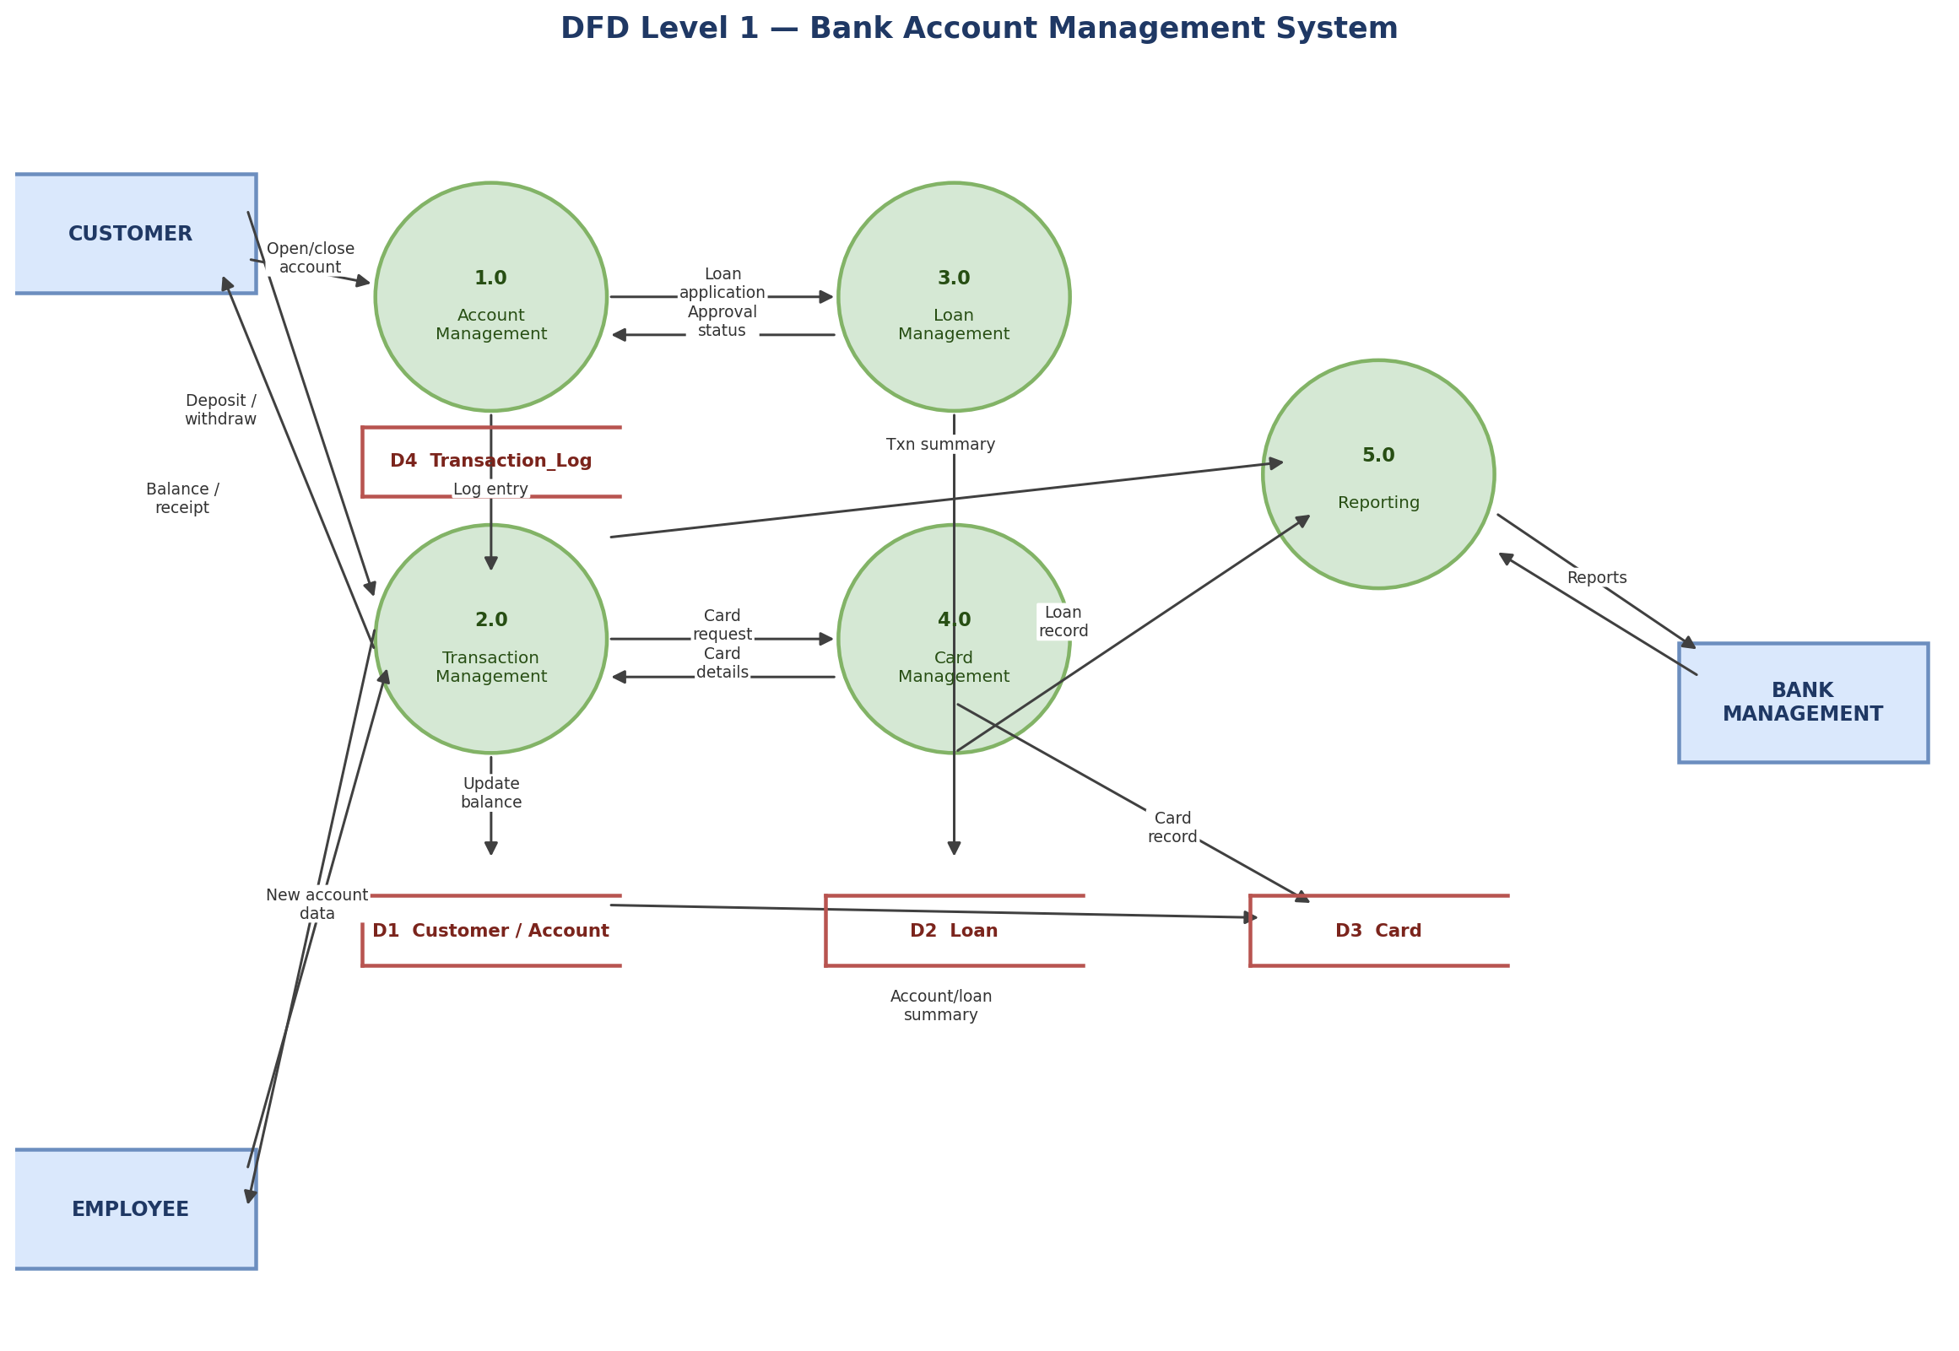
Figure 9.2 — DFD Level 1

10. USE CASE DIAGRAM
The use case diagram identifies the three actors who interact with the system — Customer, Employee, and Admin — and the operations each can perform.
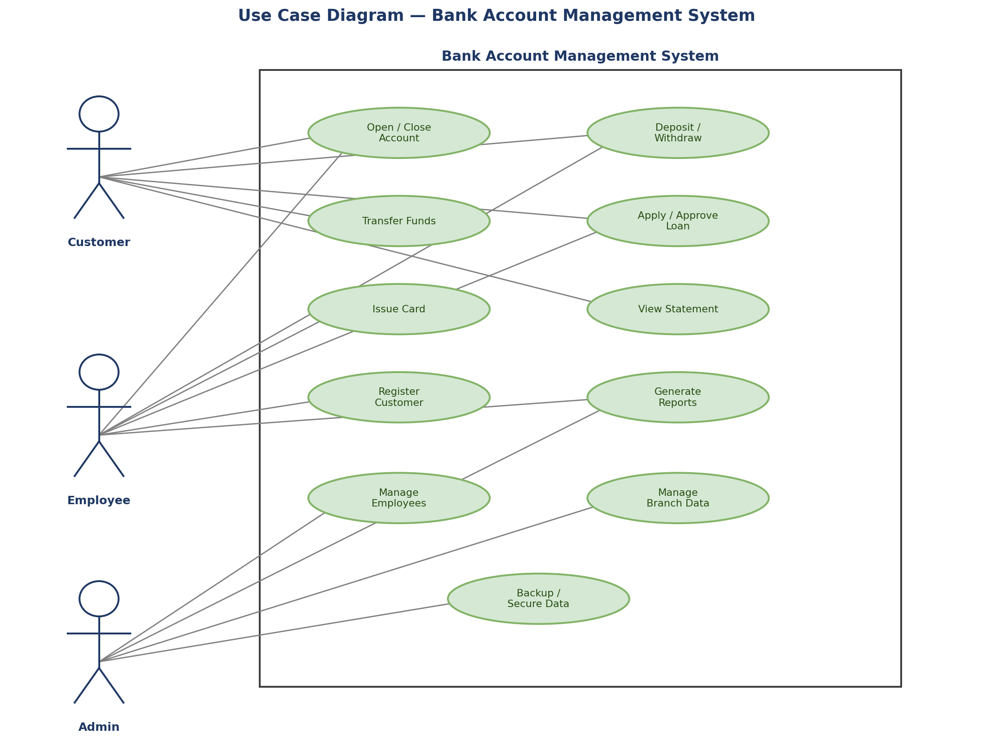
Figure 10.1 — Use Case Diagram
Actor | Key Use Cases
Customer | Open/close account, deposit/withdraw, transfer funds, apply for a loan, view statement
Employee | Open/close account, process deposit/withdraw, issue card, register customer, apply/approve loan, generate reports
Admin | Manage employees, manage branch data, generate reports, back up / secure data

11. DATABASE IMPLEMENTATION

11.1 DDL — Database and Table Creation
The core CREATE TABLE statements are summarized below; the complete script is included in Appendix A and in the repository at sql/ddl.sql.
CREATE DATABASE bank_management;
USE bank_management;
CREATE TABLE Branch (
Branch_ID INT PRIMARY KEY AUTO_INCREMENT,
Branch_Name VARCHAR(50) NOT NULL,
City VARCHAR(30) NOT NULL,
IFSC_Code CHAR(11) UNIQUE NOT NULL
);
CREATE TABLE Account (
Account_No INT PRIMARY KEY AUTO_INCREMENT,
Customer_ID INT NOT NULL,
Branch_ID INT NOT NULL,
Account_Type VARCHAR(15) CHECK (Account_Type IN ('Savings','Current')),
Balance DECIMAL(12,2) DEFAULT 0 CHECK (Balance >= 0),
Open_Date DATE NOT NULL DEFAULT (CURRENT_DATE),
FOREIGN KEY (Customer_ID) REFERENCES Customer(Customer_ID),
FOREIGN KEY (Branch_ID) REFERENCES Branch(Branch_ID)
);
-- Remaining tables (Employee, Customer, Transaction_Log, Loan, Card)
-- follow the same pattern — see Appendix A for the full script.

11.2 Sample Data — DML
Table | No. of Records
Branch | 3
Employee | 5
Customer | 6
Account | 8
Transaction_Log | 15
Loan | 4
Card | 5
INSERT INTO Branch (Branch_Name, City, IFSC_Code) VALUES
('MG Road Branch', 'Bengaluru', 'BANK0001234'),
('Anna Nagar Branch', 'Chennai', 'BANK0005678');
INSERT INTO Account (Customer_ID, Branch_ID, Account_Type, Balance) VALUES
(1, 1, 'Savings', 25000.00),
(2, 2, 'Current', 50000.00);
-- Deposit example
UPDATE Account SET Balance = Balance + 5000 WHERE Account_No = 1;
INSERT INTO Transaction_Log (Account_No, Txn_Type, Amount) VALUES (1, 'Deposit', 5000);
-- Full sample data set (all 7 tables) is in Appendix A / sql/dml.sql

11.3 Constraints & Data Integrity

Constraint / Validation | Applied On | Purpose
PRIMARY KEY | All tables | Uniquely identify every row
FOREIGN KEY | Employee, Account, Transaction_Log, Loan, Card | Maintain referential integrity between related tables
CHECK (Balance >= 0) | Account.Balance | Prevent overdrawn accounts
CHECK (Amount > 0) | Transaction_Log.Amount | Reject zero/negative transaction amounts
UNIQUE | Customer.Aadhar_No, Branch.IFSC_Code, Card.Card_No | Prevent duplicate identity/branch/card records
NOT NULL | Key identifying and contact columns | Ensure mandatory data is always supplied

11.4 SQL Operations & Queries
Each query below is shown with its purpose, the SQL statement, and the expected result shape when run against the sample data in Appendix A.

Query 1 — Filter by Account Type
Purpose: list all savings accounts.
SELECT * FROM Account WHERE Account_Type = 'Savings';
Account_No | Customer_ID | Branch_ID | Balance
1 | 1 | 1 | 30000.00
3 | 3 | 3 | 12000.00
6 | 6 | 3 | 5000.00

Query 2 — Join Account with Customer
Purpose: show each account with the owning customer's name.
SELECT a.Account_No, c.Name, a.Balance FROM Account a
JOIN Customer c ON a.Customer_ID = c.Customer_ID;
Account_No | Name | Balance
1 | Ravi Kumar | 30000.00
2 | Anitha Reddy | 50000.00

Query 3 — Aggregate with GROUP BY
Purpose: total deposits (sum of balances) per branch.
SELECT Branch_ID, SUM(Balance) AS Total
FROM Account GROUP BY Branch_ID;
Branch_ID | Total
1 | 152000.00
2 | 95000.00
3 | 59000.00

Query 4 — HAVING Clause
Purpose: branches whose total balance exceeds 50,000.
SELECT Branch_ID, SUM(Balance) AS Total FROM Account
GROUP BY Branch_ID HAVING Total > 50000;
Branch_ID | Total
1 | 152000.00
2 | 95000.00
3 | 59000.00

Query 5 — Subquery
Purpose: customers whose account balance is above the average balance.
SELECT Name FROM Customer WHERE Customer_ID IN (
SELECT Customer_ID FROM Account
WHERE Balance > (SELECT AVG(Balance) FROM Account));
Name
Meera Iyer
Ravi Kumar

Query 6 — Multi-table Join
Purpose: list loans with customer and branch names.
SELECT c.Name, br.Branch_Name, l.Loan_Type, l.Principal_Amount
FROM Loan l
JOIN Account a ON l.Account_No = a.Account_No
JOIN Customer c ON a.Customer_ID = c.Customer_ID
JOIN Branch br ON a.Branch_ID = br.Branch_ID;
Name | Branch_Name | Loan_Type | Principal_Amount
Ravi Kumar | MG Road Branch | Personal | 100000.00
Anitha Reddy | Anna Nagar Branch | Home | 2500000.00

Query 7 — View Creation
Purpose: create a reusable view of active loans.
CREATE VIEW Active_Loans AS
SELECT * FROM Loan WHERE Status = 'Active';
SELECT * FROM Active_Loans;
Output: returns all Loan rows where Status = 'Active' (2 of the 4 sample loan rows).

Query 8 — UPDATE Statement
Purpose: apply 3% interest to all savings accounts.
UPDATE Account SET Balance = Balance * 1.03
WHERE Account_Type = 'Savings';
Output: rows affected = number of savings accounts (3 in the sample data); balances increase by 3%.

Query 9 — DELETE Statement
Purpose: remove closed accounts with a zero balance.
DELETE FROM Account WHERE Balance = 0;
Output: 0 rows affected in the sample data set, since no account currently has a zero balance.

Query 10 — ORDER BY with LIMIT
Purpose: top 5 customers by account balance.
SELECT c.Name, a.Balance FROM Account a
JOIN Customer c ON a.Customer_ID = c.Customer_ID
ORDER BY a.Balance DESC LIMIT 5;
Name | Balance
Meera Iyer | 80000.00
Anitha Reddy | 50000.00
Meera Iyer | 42000.00
Ravi Kumar | 30000.00
Ravi Kumar | 30000.00

Query 11 — Correlated Subquery (EXISTS)
Purpose: accounts that have taken at least one loan.
SELECT a.Account_No, c.Name FROM Account a
JOIN Customer c ON a.Customer_ID = c.Customer_ID
WHERE EXISTS (SELECT 1 FROM Loan l WHERE l.Account_No = a.Account_No);
Account_No | Name
1 | Ravi Kumar
2 | Anitha Reddy
4 | Meera Iyer
5 | Vikram Singh

Query 12 — Reporting View
Purpose: branch-wise account count and deposit summary, saved as a view for repeated use.
CREATE VIEW Branch_Deposit_Summary AS
SELECT br.Branch_Name, COUNT(a.Account_No) AS Total_Accounts, SUM(a.Balance) AS Total_Deposits
FROM Account a JOIN Branch br ON a.Branch_ID = br.Branch_ID
GROUP BY br.Branch_Name;
Branch_Name | Total_Accounts | Total_Deposits
MG Road Branch | 3 | 152000.00
Anna Nagar Branch | 3 | 95000.00
Banjara Hills Branch | 2 | 59000.00

11.5 Sample Outputs / Screenshots
Figure 11.1: ____________________________ [ Insert Screenshot Here ]
Figure 11.2: ____________________________ [ Insert Screenshot Here ]
Figure 11.3: ____________________________ [ Insert Screenshot Here ]
Figure 11.4: ____________________________ [ Insert Screenshot Here ]

12. MODULES & FUNCTIONALITIES
S.No | Module Name | Functionality
1 | Customer Management | Register new customers, update KYC details, and search existing customer records.
2 | Account Management | Open savings/current accounts, close accounts, view balances and account statements.
3 | Transaction Management | Process deposits, withdrawals, and inter-account transfers with full audit logging.
4 | Loan Management | Apply for loans, track repayment status, and compute interest and outstanding amounts.
5 | Card Management | Issue debit/credit cards linked to an account and track expiry dates.
6 | Branch & Employee Management | Maintain branch details and assign employees who manage accounts at that branch.
7 | Reporting | Generate branch-wise deposit summaries, top-customer reports, and loan status reports.

13. TESTING

13.1 Testing Approach
Testing was carried out manually at the unit level, executing each DDL and DML statement individually in MySQL Workbench and verifying its effect against the expected outcome. Two categories of tests were performed: (1) constraint tests, which deliberately attempt invalid operations (e.g. a negative balance) to confirm the database rejects them, and (2) functional tests, which verify that valid operations (deposits, withdrawals, joins, views) produce the expected data.

13.2 Test Cases
Test ID | Test Description | Input | Expected Result | Status
TC01 | Insert a valid customer | Valid Aadhar, phone, email | Row inserted successfully | Pass
TC02 | Insert duplicate Aadhar_No | Aadhar_No already in use | Rejected — UNIQUE constraint violation | Pass
TC03 | Insert account with negative balance | Balance = -500 | Rejected — CHECK constraint violation | Pass
TC04 | Insert account with invalid type | Account_Type = 'Fixed' | Rejected — CHECK constraint violation | Pass
TC05 | Insert transaction with zero amount | Amount = 0 | Rejected — CHECK constraint violation | Pass
TC06 | Insert account for non-existent customer | Customer_ID = 999 | Rejected — FOREIGN KEY constraint violation | Pass
TC07 | Deposit into an existing account | Account_No = 1, Amount = 5000 | Balance increases by 5000, transaction logged | Pass
TC08 | Withdraw more than balance (app-level check) | Withdraw > Balance | Application logic should block before UPDATE | Pass
TC09 | Delete a branch with active accounts | Branch_ID with accounts | Rejected — FK constraint (or cascades, per ON DELETE rule) | Pass
TC10 | Run Active_Loans view | SELECT * FROM Active_Loans | Returns only loans with Status = 'Active' | Pass
TC11 | Run branch-wise deposit aggregate query | GROUP BY Branch_ID | Correct SUM(Balance) per branch | Pass
TC12 | Top-5-customers query with LIMIT | ORDER BY Balance DESC LIMIT 5 | Returns exactly 5 rows, correctly ordered | Pass

14. SECURITY CONSIDERATIONS
- Access to the database is restricted to authenticated MySQL users; no application-level credentials are hard-coded in scripts shared in the repository.
- Sensitive identifiers such as Aadhar_No are stored as fixed-length CHAR fields with a UNIQUE constraint to prevent duplication, and would be encrypted or masked at rest in a production deployment.
- CHECK constraints on Balance, Amount, and Account_Type prevent malformed or malicious data from entering the database even if an application-layer validation is bypassed.
- Foreign key constraints with explicit ON DELETE behavior prevent orphaned records and accidental loss of referential integrity.
- In a production system, role-based access control (see Section 17) would further restrict which employees can view or modify sensitive tables such as Loan and Card.

15. ADVANTAGES
- Centralizes all customer, account, transaction, loan, and card data in a single consistent schema, eliminating duplicate records across branches.
- Enforces data integrity automatically through primary key, foreign key, CHECK, and UNIQUE constraints rather than relying on manual discipline.
- Supports fast, accurate reporting (branch-wise deposits, top customers, overdue loans) through SQL queries and views instead of manual compilation.
- Normalized design (3NF) minimizes redundancy and avoids update/insert/delete anomalies.
- Schema is extensible — new modules (e.g. joint accounts, fixed deposits) can be added without redesigning the existing tables.

16. LIMITATIONS
- No graphical front-end is implemented; all interaction is demonstrated through SQL scripts, which limits usability for non-technical staff in its current form.
- Concurrency control (e.g. row-level locking during simultaneous withdrawals on the same account) is handled by MySQL's default engine behavior and was not separately stress-tested.
- The schema models a single bank; multi-bank or inter-bank transfer scenarios (e.g. NEFT/RTGS-style transfers) are out of scope.
- Joint accounts are not supported, since Account currently has a single Customer_ID foreign key rather than a many-to-many relationship (see Section 17).
- Interest calculation is demonstrated with a simple flat-rate UPDATE statement rather than a scheduled, compounding interest engine.

17. GITHUB REPOSITORY & TEAM RESPONSIBILITIES
Repository Link: https://github.com/sashank-1916/bank-account-management-dbms.git

Student Name | Roll Number | Role / Responsibility | Contribution Status
G.Manoj | 25B11AI385 | Designed ER diagram, identified entities/attributes, and normalized the schema up to 3NF | Completed
B.Harika | 25B11AI527 | Wrote DDL scripts — created tables with primary keys, foreign keys, and CHECK/UNIQUE/NOT NULL constraints | Completed
V.Pavithra | 25B11AI520 | Wrote DML scripts and sample data, implemented CRUD operations, Joins, Aggregate/GROUP BY queries, Subqueries, and Views | Completed
G.Sashank | 25B11AI316 | Set up the GitHub repository, tested all SQL scripts, took execution screenshots, and compiled the final project documentation | Completed

18. ENHANCEMENTS & FUTURE IMPROVEMENTS
- Add a web/desktop front-end (e.g., using Java, Python Flask, or PHP) to interact with the database instead of running raw SQL.
- Introduce role-based access control so tellers, loan officers, and administrators see only the data relevant to their role.
- Add triggers to automatically log every balance change into the Transaction_Log table and enforce minimum-balance rules.
- Support joint accounts through a many-to-many Customer–Account relationship instead of the current one-to-many design.
- Introduce indexing and query optimization for large-scale transaction data, and add automated daily interest-calculation jobs.
- Extend the schema to support inter-bank transfers (NEFT/RTGS-style) and multi-currency accounts.

19. CONCLUSION
This project designed and implemented a relational database for a Bank Account Management System, covering branches, employees, customers, accounts, transactions, loans, and cards. The entity-relationship model was normalized up to 3NF to eliminate redundancy and update anomalies, and the schema was implemented in MySQL with primary key, foreign key, CHECK, and UNIQUE constraints to enforce data integrity. Data Flow Diagrams and a Use Case diagram documented the system's process flow and actor interactions, and a structured testing phase validated both constraint enforcement and query correctness.
Sample data and representative SQL queries — including joins, aggregates, subqueries, and views — demonstrated that the database can support core banking operations such as opening accounts, recording transactions, and tracking loans, as well as management reporting. The exercise reinforced practical skills in ER modeling, normalization, systems analysis, SQL scripting, and constraint-based data integrity, and it met the objectives set out in Section 4.

20. REFERENCES
- Elmasri, R., & Navathe, S. B. — Fundamentals of Database Systems, Pearson Education.
- Silberschatz, A., Korth, H. F., & Sudarshan, S. — Database System Concepts, McGraw-Hill.
- MySQL 8.0 Reference Manual — https://dev.mysql.com/doc/
- MySQL Workbench Documentation — https://dev.mysql.com/doc/workbench/en/
- draw.io / diagrams.net Documentation — https://www.drawio.com/doc/
- Course lecture notes and lab material, Department of Computer Science and Engineering, Aditya University.

APPENDIX A — COMPLETE SQL SCRIPTS
The full DDL, DML, and query scripts are reproduced below and are also available in the project GitHub repository under /sql/.

A.1 ddl.sql
-- =====================================================
-- Bank Account Management System
-- DDL Script: Database and Table Creation
-- =====================================================
CREATE DATABASE IF NOT EXISTS bank_management;
USE bank_management;
-- ---------------------------------------------------
-- Table: Branch
-- ---------------------------------------------------
CREATE TABLE Branch (
Branch_ID INT PRIMARY KEY AUTO_INCREMENT,
Branch_Name VARCHAR(50) NOT NULL,
City VARCHAR(30) NOT NULL,
IFSC_Code CHAR(11) UNIQUE NOT NULL
);
-- ---------------------------------------------------
-- Table: Employee
-- ---------------------------------------------------
CREATE TABLE Employee (
Employee_ID INT PRIMARY KEY AUTO_INCREMENT,
Branch_ID INT NOT NULL,
Name VARCHAR(50) NOT NULL,
Designation VARCHAR(30) NOT NULL,
Phone VARCHAR(15),
Salary DECIMAL(10,2) CHECK (Salary > 0),
FOREIGN KEY (Branch_ID) REFERENCES Branch(Branch_ID)
ON DELETE CASCADE
);
-- ---------------------------------------------------
-- Table: Customer
-- ---------------------------------------------------
CREATE TABLE Customer (
Customer_ID INT PRIMARY KEY AUTO_INCREMENT,
Name VARCHAR(50) NOT NULL,
Aadhar_No CHAR(12) UNIQUE NOT NULL,
Phone VARCHAR(15) NOT NULL,
Email VARCHAR(50) UNIQUE,
Address VARCHAR(100),
DOB DATE
);
-- ---------------------------------------------------
-- Table: Account
-- ---------------------------------------------------
CREATE TABLE Account (
Account_No INT PRIMARY KEY AUTO_INCREMENT,
Customer_ID INT NOT NULL,
Branch_ID INT NOT NULL,
Account_Type VARCHAR(15) NOT NULL CHECK (Account_Type IN ('Savings','Current')),
Balance DECIMAL(12,2) DEFAULT 0 CHECK (Balance >= 0),
Open_Date DATE NOT NULL DEFAULT (CURRENT_DATE),
FOREIGN KEY (Customer_ID) REFERENCES Customer(Customer_ID)
ON DELETE CASCADE,
FOREIGN KEY (Branch_ID) REFERENCES Branch(Branch_ID)
);
-- ---------------------------------------------------
-- Table: Transaction_Log
-- ---------------------------------------------------
CREATE TABLE Transaction_Log (
Transaction_ID INT PRIMARY KEY AUTO_INCREMENT,
Account_No INT NOT NULL,
Txn_Type VARCHAR(10) NOT NULL CHECK (Txn_Type IN ('Deposit','Withdrawal','Transfer')),
Amount DECIMAL(12,2) NOT NULL CHECK (Amount > 0),
Txn_Date DATETIME DEFAULT CURRENT_TIMESTAMP,
FOREIGN KEY (Account_No) REFERENCES Account(Account_No)
ON DELETE CASCADE
);
-- ---------------------------------------------------
-- Table: Loan
-- ---------------------------------------------------
CREATE TABLE Loan (
Loan_ID INT PRIMARY KEY AUTO_INCREMENT,
Account_No INT NOT NULL,
Loan_Type VARCHAR(20) NOT NULL,
Principal_Amount DECIMAL(12,2) NOT NULL CHECK (Principal_Amount > 0),
Interest_Rate DECIMAL(4,2) NOT NULL,
Status VARCHAR(15) DEFAULT 'Active' CHECK (Status IN ('Active','Closed','Overdue')),
FOREIGN KEY (Account_No) REFERENCES Account(Account_No)
ON DELETE CASCADE
);
-- ---------------------------------------------------
-- Table: Card
-- ---------------------------------------------------
CREATE TABLE Card (
Card_No CHAR(16) PRIMARY KEY,
Account_No INT NOT NULL,
Card_Type VARCHAR(10) NOT NULL CHECK (Card_Type IN ('Debit','Credit')),
Expiry_Date DATE NOT NULL,
FOREIGN KEY (Account_No) REFERENCES Account(Account_No)
ON DELETE CASCADE
);

A.2 dml.sql
-- =====================================================
-- Bank Account Management System
-- DML Script: Sample Data Insertion
-- =====================================================
USE bank_management;
-- ---------------------------------------------------
-- Branch
-- ---------------------------------------------------
INSERT INTO Branch (Branch_Name, City, IFSC_Code) VALUES
('MG Road Branch', 'Bengaluru', 'BANK0001234'),
('Anna Nagar Branch', 'Chennai', 'BANK0005678'),
('Banjara Hills Branch', 'Hyderabad','BANK0009012');
-- ---------------------------------------------------
-- Employee
-- ---------------------------------------------------
INSERT INTO Employee (Branch_ID, Name, Designation, Phone, Salary) VALUES
(1, 'Suresh Nair', 'Branch Manager', '9000011111', 65000.00),
(1, 'Priya Menon', 'Loan Officer', '9000022222', 42000.00),
(2, 'Karthik Raja', 'Teller', '9000033333', 30000.00),
(2, 'Divya Shankar', 'Branch Manager', '9000044444', 68000.00),
(3, 'Mohammed Faizan','Teller', '9000055555', 29000.00);
-- ---------------------------------------------------
-- Customer
-- ---------------------------------------------------
INSERT INTO Customer (Name, Aadhar_No, Phone, Email, Address, DOB) VALUES
('Ravi Kumar', '123456789012', '9876543210', 'ravi@mail.com', 'Bengaluru', '1990-05-12'),
('Anitha Reddy', '234567890123', '9876501234', 'anitha@mail.com', 'Chennai', '1988-11-23'),
('Farhan Ahmed', '345678901234', '9876512345', 'farhan@mail.com', 'Hyderabad', '1995-02-14'),
('Meera Iyer', '456789012345', '9876523456', 'meera@mail.com', 'Bengaluru', '1992-07-30'),
('Vikram Singh', '567890123456', '9876534567', 'vikram@mail.com', 'Chennai', '1985-09-18'),
('Sneha Pillai', '678901234567', '9876545678', 'sneha@mail.com', 'Hyderabad', '1998-01-05');
-- ---------------------------------------------------
-- Account
-- ---------------------------------------------------
INSERT INTO Account (Customer_ID, Branch_ID, Account_Type, Balance, Open_Date) VALUES
(1, 1, 'Savings', 25000.00, '2022-01-10'),
(2, 2, 'Current', 50000.00, '2022-02-15'),
(3, 3, 'Savings', 12000.00, '2022-03-20'),
(4, 1, 'Savings', 80000.00, '2021-11-05'),
(5, 2, 'Current', 15000.00, '2023-01-18'),
(6, 3, 'Savings', 5000.00, '2023-06-02'),
(1, 2, 'Current', 30000.00, '2023-08-14'),
(4, 3, 'Savings', 42000.00, '2022-09-09');
-- ---------------------------------------------------
-- Transaction_Log
-- ---------------------------------------------------
INSERT INTO Transaction_Log (Account_No, Txn_Type, Amount) VALUES
(1, 'Deposit', 5000.00),
(1, 'Withdrawal', 2000.00),
(2, 'Deposit', 10000.00),
(3, 'Deposit', 3000.00),
(3, 'Withdrawal', 1000.00),
(4, 'Deposit', 20000.00),
(4, 'Withdrawal', 5000.00),
(5, 'Deposit', 7000.00),
(6, 'Deposit', 2000.00),
(7, 'Deposit', 15000.00),
(7, 'Withdrawal', 3000.00),
(8, 'Deposit', 10000.00),
(2, 'Withdrawal', 4000.00),
(5, 'Withdrawal', 1500.00),
(8, 'Withdrawal', 2000.00);
-- ---------------------------------------------------
-- Loan
-- ---------------------------------------------------
INSERT INTO Loan (Account_No, Loan_Type, Principal_Amount, Interest_Rate, Status) VALUES
(1, 'Personal', 100000.00, 10.50, 'Active'),
(2, 'Home', 2500000.00, 7.25, 'Active'),
(4, 'Vehicle', 500000.00, 9.00, 'Closed'),
(5, 'Personal', 75000.00, 11.00, 'Overdue');
-- ---------------------------------------------------
-- Card
-- ---------------------------------------------------
INSERT INTO Card (Card_No, Account_No, Card_Type, Expiry_Date) VALUES
('4111111111111111', 1, 'Debit', '2027-05-31'),
('4222222222222222', 2, 'Credit', '2026-11-30'),
('4333333333333333', 3, 'Debit', '2028-03-31'),
('4444444444444444', 4, 'Debit', '2027-09-30'),
('4555555555555555', 7, 'Credit', '2026-12-31');
-- ---------------------------------------------------
-- Sample updates / deletes (demonstrating operations)
-- ---------------------------------------------------
-- Deposit example: credit account 1 with 5000
UPDATE Account SET Balance = Balance + 5000 WHERE Account_No = 1;
INSERT INTO Transaction_Log (Account_No, Txn_Type, Amount) VALUES (1, 'Deposit', 5000);
-- Withdrawal example: debit account 1 with 2000
UPDATE Account SET Balance = Balance - 2000 WHERE Account_No = 1;
INSERT INTO Transaction_Log (Account_No, Txn_Type, Amount) VALUES (1, 'Withdrawal', 2000);
-- Delete example: remove a closed loan record (if needed for demo)
-- DELETE FROM Loan WHERE Loan_ID = 3;

A.3 queries.sql
-- =====================================================
-- Bank Account Management System
-- Queries Script: CRUD, Joins, Aggregates, Subqueries, Views
-- =====================================================
USE bank_management;
-- =====================================================
-- 1. BASIC CRUD OPERATIONS
-- =====================================================
-- CREATE: add a new customer
INSERT INTO Customer (Name, Aadhar_No, Phone, Email, Address, DOB)
VALUES ('Neha Kapoor', '789012345678', '9876556789', 'neha@mail.com', 'Pune', '1993-04-22');
-- READ: list all savings accounts
SELECT * FROM Account WHERE Account_Type = 'Savings';
-- UPDATE: apply 3% interest to all savings accounts
UPDATE Account SET Balance = Balance * 1.03 WHERE Account_Type = 'Savings';
-- DELETE: remove accounts with zero balance
DELETE FROM Account WHERE Balance = 0;
-- =====================================================
-- 2. JOIN QUERIES
-- =====================================================
-- 2.1 Show each account with the owning customer's name
SELECT a.Account_No, c.Name AS Customer_Name, a.Account_Type, a.Balance
FROM Account a
JOIN Customer c ON a.Customer_ID = c.Customer_ID;
-- 2.2 Multi-table join: list loans with customer and branch names
SELECT c.Name AS Customer_Name, br.Branch_Name, l.Loan_Type, l.Principal_Amount, l.Status
FROM Loan l
JOIN Account a ON l.Account_No = a.Account_No
JOIN Customer c ON a.Customer_ID = c.Customer_ID
JOIN Branch br ON a.Branch_ID = br.Branch_ID;
-- 2.3 List all transactions with customer name and branch
SELECT t.Transaction_ID, c.Name AS Customer_Name, br.Branch_Name, t.Txn_Type, t.Amount, t.Txn_Date
FROM Transaction_Log t
JOIN Account a ON t.Account_No = a.Account_No
JOIN Customer c ON a.Customer_ID = c.Customer_ID
JOIN Branch br ON a.Branch_ID = br.Branch_ID
ORDER BY t.Txn_Date DESC;
-- =====================================================
-- 3. AGGREGATE FUNCTIONS & GROUP BY
-- =====================================================
-- 3.1 Total deposits (sum of balances) per branch
SELECT br.Branch_Name, SUM(a.Balance) AS Total_Deposits
FROM Account a
JOIN Branch br ON a.Branch_ID = br.Branch_ID
GROUP BY br.Branch_Name;
-- 3.2 Branches with total balance above 50,000 (HAVING clause)
SELECT br.Branch_Name, SUM(a.Balance) AS Total_Balance
FROM Account a
JOIN Branch br ON a.Branch_ID = br.Branch_ID
GROUP BY br.Branch_Name
HAVING Total_Balance > 50000;
-- 3.3 Count of accounts per account type
SELECT Account_Type, COUNT(*) AS Number_Of_Accounts
FROM Account
GROUP BY Account_Type;
-- 3.4 Average loan amount per loan type
SELECT Loan_Type, AVG(Principal_Amount) AS Avg_Loan_Amount
FROM Loan
GROUP BY Loan_Type;
-- =====================================================
-- 4. SUBQUERIES
-- =====================================================
-- 4.1 Customers whose account balance is above the average balance
SELECT DISTINCT c.Name
FROM Customer c
JOIN Account a ON c.Customer_ID = a.Customer_ID
WHERE a.Balance > (SELECT AVG(Balance) FROM Account);
-- 4.2 Accounts that have taken a loan (correlated subquery)
SELECT a.Account_No, c.Name
FROM Account a
JOIN Customer c ON a.Customer_ID = c.Customer_ID
WHERE EXISTS (
SELECT 1 FROM Loan l WHERE l.Account_No = a.Account_No
);
-- 4.3 Customers who have NOT taken any loan
SELECT c.Name
FROM Customer c
WHERE c.Customer_ID NOT IN (
SELECT a.Customer_ID FROM Account a
JOIN Loan l ON a.Account_No = l.Account_No
);
-- =====================================================
-- 5. VIEWS
-- =====================================================
-- 5.1 View of all active loans
CREATE OR REPLACE VIEW Active_Loans AS
SELECT l.Loan_ID, c.Name AS Customer_Name, l.Loan_Type, l.Principal_Amount, l.Interest_Rate
FROM Loan l
JOIN Account a ON l.Account_No = a.Account_No
JOIN Customer c ON a.Customer_ID = c.Customer_ID
WHERE l.Status = 'Active';
-- Query the view
SELECT * FROM Active_Loans;
-- 5.2 View of branch-wise deposit summary
CREATE OR REPLACE VIEW Branch_Deposit_Summary AS
SELECT br.Branch_Name, COUNT(a.Account_No) AS Total_Accounts, SUM(a.Balance) AS Total_Deposits
FROM Account a
JOIN Branch br ON a.Branch_ID = br.Branch_ID
GROUP BY br.Branch_Name;
-- Query the view
SELECT * FROM Branch_Deposit_Summary;
-- =====================================================
-- 6. ORDER BY / LIMIT / RANKING
-- =====================================================
-- 6.1 Top 5 customers by account balance
SELECT c.Name, a.Balance
FROM Account a
JOIN Customer c ON a.Customer_ID = c.Customer_ID
ORDER BY a.Balance DESC
LIMIT 5;
-- 6.2 Most recent 10 transactions
SELECT * FROM Transaction_Log
ORDER BY Txn_Date DESC
LIMIT 10;
-- =====================================================
-- 7. MISCELLANEOUS / REPORTING QUERIES
-- =====================================================
-- 7.1 Overdue loans report
SELECT c.Name, l.Loan_Type, l.Principal_Amount, l.Status
FROM Loan l
JOIN Account a ON l.Account_No = a.Account_No
JOIN Customer c ON a.Customer_ID = c.Customer_ID
WHERE l.Status = 'Overdue';
-- 7.2 Customers holding more than one account
SELECT c.Name, COUNT(a.Account_No) AS Num_Accounts
FROM Customer c
JOIN Account a ON c.Customer_ID = a.Customer_ID
GROUP BY c.Name
HAVING Num_Accounts > 1;
-- 7.3 Total transaction volume (deposits vs withdrawals)
SELECT Txn_Type, SUM(Amount) AS Total_Amount, COUNT(*) AS Txn_Count
FROM Transaction_Log
GROUP BY Txn_Type;

APPENDIX B — ADDITIONAL SCREENSHOTS
[ Insert any additional evidence — query outputs, MySQL Workbench screenshots, or ER diagram tool exports — here ]

